VINH LONG UNIVERSITY OF TECHNOLOGY EDUCATION

**PRACTICE CENTER**

TEST PROJECT

PRACTICAL SKILLS

MODULE 1: WEB DESIGN

**Exam Paper Code: WD01**

|  |  |
| --- | --- |
| **SCHOOL LEADERSHIP** | **CHIEF SUBCOMMITTEE ON EXAM DEVELOPMENT** |

**Vinh Long, month 12/2020**

**GUIDE CONTESTANTS**

**Time:**

* Preparation Time: 05 minutes
* Time Duration: 150 minutes
* Break Time: 10 minutes

**Scores:**

|  |  |  |
| --- | --- | --- |
| **Exam content** | | **Marks** |
| 1 | Programming with HTML/CSS | 30 |
| 2 | Programming with JavaScript | 30 |
| 3 | Use the MySQL | 10 |
| 4 | Programming with PHP | 30 |
| **Total Marks** | | **100** |

**Candidates are required to note:**

* Ensure safety standards of health and computer
* Do the test independently without discussing while doing the test
* Comply with regulations of exam room and proctor’s instructions
* Fill the information in the form
* Complete all requirements in the content of the exam
* Do not use documents, the Internet and other communication devices during the assignment
* If the exam does not have special requirement for the file name and storage location, contestants save all exam file name in the folder as following format**: D:\WorkSkills\Web Design\**

***<Student’s Name>_<*** ***Student code >[.<*** ***extension >]***

**CONTENT OF THE TEST**

**Question 1:**

**Programming with** **HTML/CSS:**

Use HTML/CSS code to design the following page:

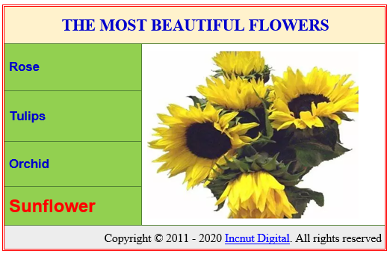

# **DESCRIPTION OF PROJECT AND TASKS**

* + Use the images in folder \\Web Design\Flowers.
  + Make heading “**THE MOST BEAUTIFUL FLOWERS**” is blue, bolders and make them use Times New Roman font (or any serif font on the system), bold and center align.
  + List flowers is blue color and left align.
  + Border of the table is double dash style and red color.
  + Border of rows is single dash and green color
  + Last row “Incnut Digtal” link to <https://www.stylecraze.com/> and right align.
  + When mouse over any name of flower in list flower then show image of the flower at the right column and title the flower change to red color and size larger size.
  + Set size of the image flower is the same and fit to the right column.
  + Save the file with name Flower.html

**Question 2:**

**Programming with** **JavaScript:**

Write the necessary JavaScript code **Puzzle_Move.js** for the functionality of the following page:

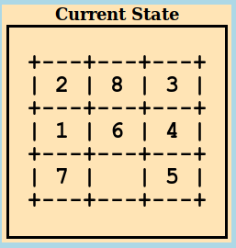

**DESCRIPTION OF PROJECT AND TASKS**

* Create the table has 3 rows and 3 columns.
* Each cell gets a value random between 0 and 8.
* Value of each cell is unique.
* Assign blank value for cell has 0 value.
* When user is pressing left_click on any cells then the value of cell turns red color.
* After the user has clicked, the values of all cell turn black color.
* If the adjacent cell is been clicking blank cell then the content of those 2 cells will be swapped.

**Question 3:**

**Use the MySQL create database with name *Mana_ commodity*:**

***The database schema:***

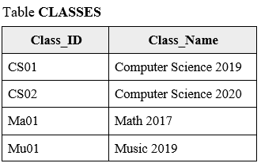

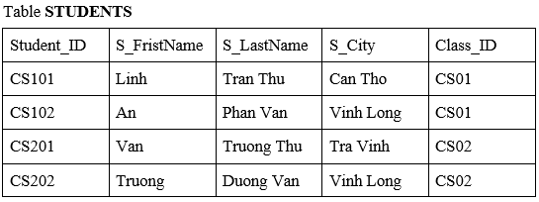

**DESCRIPTION OF PROJECT AND TASKS**

* Create database with name ***Mana_ commodity***
* In database ***Mana_ commodity*** create table CLASSES and table STUDENTS
* Choose appropriate data type for the fields.
* Create relationship for the above tables.
* Insert data for the tables as above.

**Question 4:**

**Programming with** **PHP:**

Use database ***Mana_ commodity*** from ***Question 3*** write a page that displays the result of a query in PHP. Create a new PHP file and save the file as SearchStudent.php.

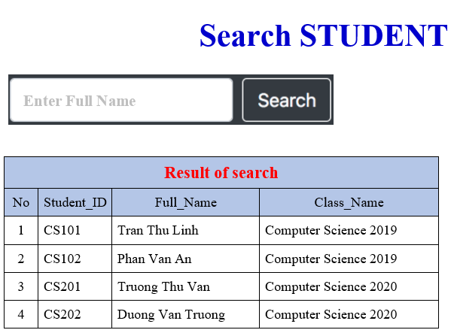

**DESCRIPTION OF PROJECT AND TASKS**

* + Create title “Search STUDENT”
  + Create text to Enter full Name
  + Create button Search
  + Create table “Result of search”
* Create event for button Search.
* If content search is blank then show all students as table “Result of search”.
* If content search is not blank then show students whose full name is similar to the search text

**GENERAL TRANSCRIPT**

|  |  |  |  |
| --- | --- | --- | --- |
| **Exam content** | | **Maximum Marks** | **Achieved**  **Marks** |
| 1 | Programming with HTML/CSS | 30 |  |
| 2 | Programming with JavaScript | 30 |  |
| 3 | Use the MySQL | 10 |  |
| 4 | Programming with PHP | 30 |  |
| **Total Marks** | | **100** |  |

**TEST TIME**

|  |  |  |  |  |  |  |  |
| --- | --- | --- | --- | --- | --- | --- | --- |
| **Get to know the equipment** | | **Time Duration** | | **Break Time** | | | |
| Starting time |  | Starting time |  | Starting time |  | Starting time |  |
| Ending time |  | Ending time |  | Ending time |  | Ending time |  |

**TEACHERS’ SIGNATURE**

|  |  |  |  |  |
| --- | --- | --- | --- | --- |
| **1** | **2** | **3** | **4** | **5** |
|  |  |  |  |  |